**NAME : Shaik .Abdul Moiz**

**Student ID:11620657.**

**ITC 515:Professional programming practice.**

**Assignment 2:Team Work-version control-Static code Review**

**Summary**

Professional programming practice contains four Aspects, namely: teamwork, version control, testing, and debugging.To do team work,We created a group “Strong Ties” ,which makes to engage all team members.Our team members are in the following:

1.Hasan Ali

2.Mohammad Javed

3.Shaik.Abdul Moiz

4.Akshith reddy.

**Assignment 2 Task 1: Team Work:**

We make a meeting at Monday 12;30 at college and discuss about the iteration plan.

* Evidence for the attendance in the iteration evaluation is in the following:

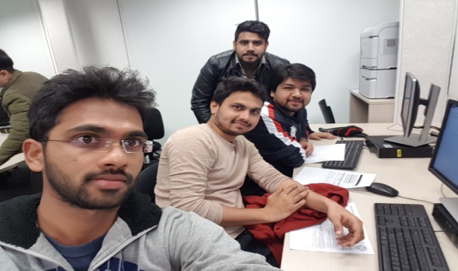

* <https://b24n5987ca0d83217.bitrix24.com/company/personal/user/1/calendar/?EVENT_ID=2&EVENT_DATE=08/24/2017%2010:35:00%20pm>
* 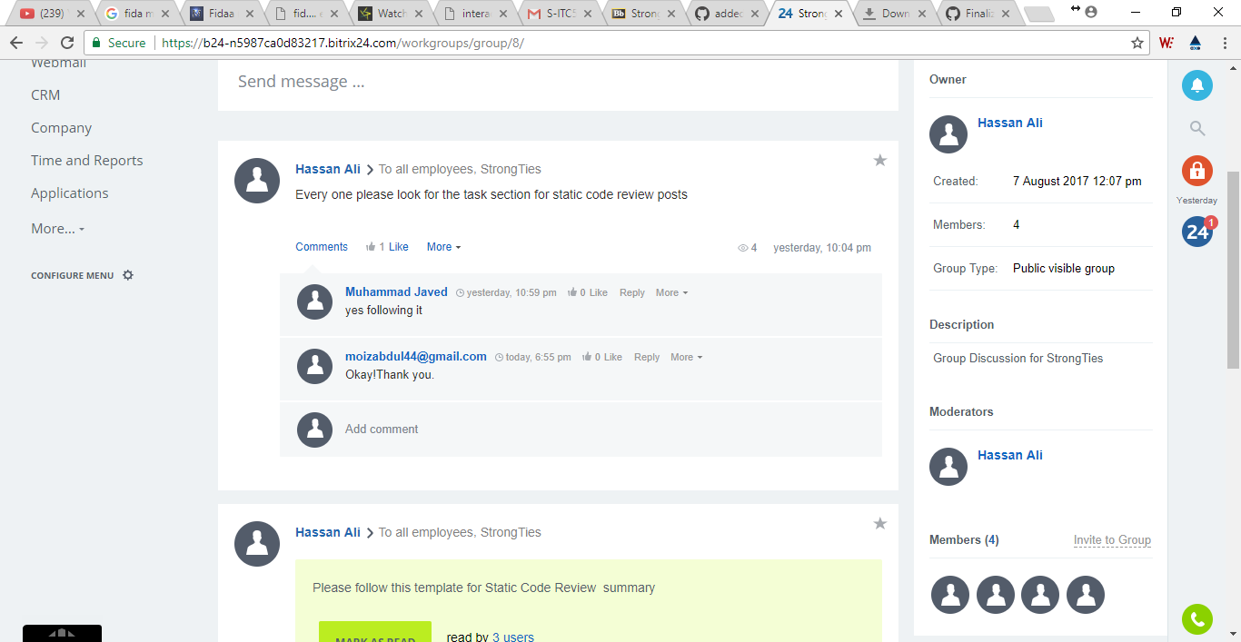
* We scheduled work items to given BCCCP project in Iteration plan Draft which is in the following:
* 
* We discussed and planned work items to be completed in given time.
* 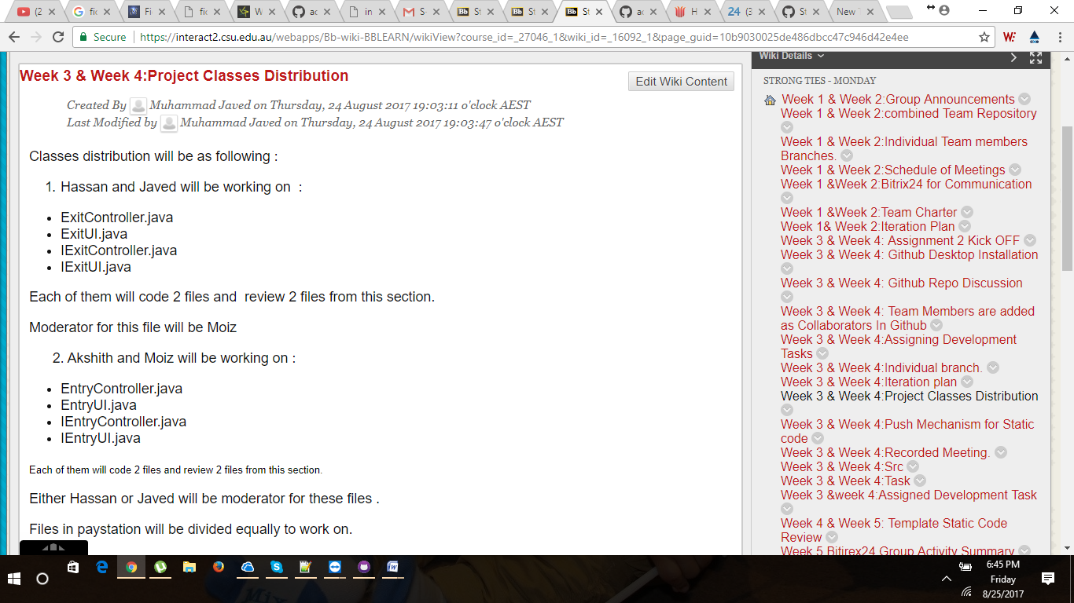
* To coordinate our development activities, we Selected Push communication mechanism and evidence for collaboration is in the following:
* 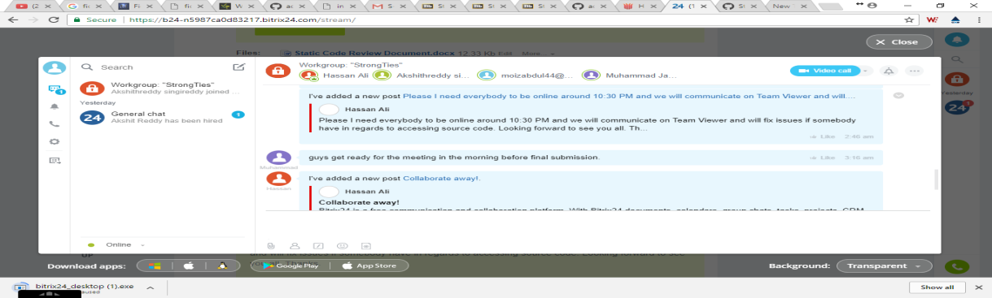

**Task2: Version Control:**

* As a Team, downloaded source files in Github which is in the following link:
* [https://github.com/engrhxn/Strong.Ties](https://github.com/engrhxn/Strong-Ties-CarPark)
* 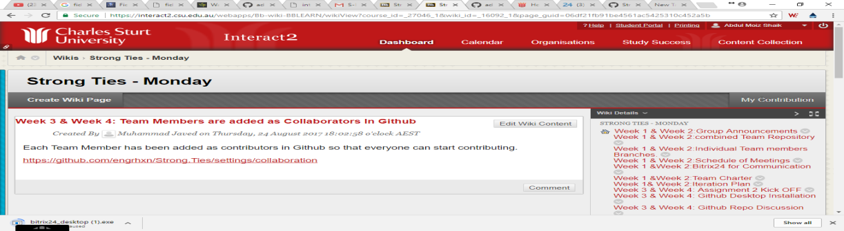
* Individual Branch of my own line code development.
* <https://github.com/engrhxn/Strong.Ties/tree/Moiz>
* Assigned development task link for me is in the below:
* [https://github.com/engrhxn/Strong.Ties/blob/Moiz/src/bcccp/carpark/entry/EntryController.java](https://github.com/ashaik10/Strong-Ties/blob/A1/EntryController.java)
* As a team,we conduct a formal code review and submitted by this template.
* [Static Code Review Document.docx](https://interact2.csu.edu.au/bbcswebdav/internal/courses/S-ITC515_201760_SM_I/wikis/group/5f918e07725d44ba90c66a271abb0ed6/02ce00b6b26245a294a43ea3c88937ce/Static%20Code%20Review%20Document.docx)

**Task 3: Static code Review**

* My Assigned development Task in the BCCCP project is Entry Car Park Class.I have done the code for Entry controller.Java as a “AUTHOR”.
* Mediator and Reviewer details in Static Code Review Doc which is in the below:
* **As a Author:**

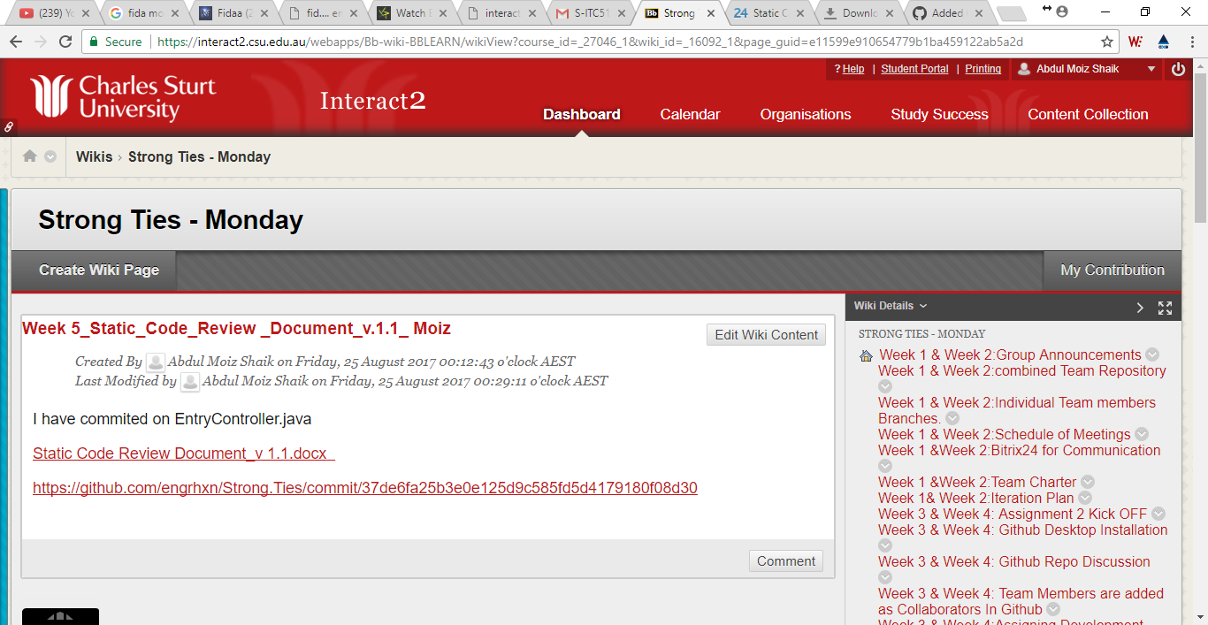

* [Static Code Review Document_v 1.1.docx](https://interact2.csu.edu.au/bbcswebdav/internal/courses/S-ITC515_201760_SM_I/wikis/group/5f918e07725d44ba90c66a271abb0ed6/e11599e910654779b1ba459122ab5a2d/Static%20Code%20Review%20Document_v%20%201.1.docx)
* <https://github.com/engrhxn/Strong.Ties/commit/37de6fa25b3e0e125d9c585fd5d4179180f08d30>
* I have added buttonpushed and ticketinserted to Entrycontroller.
* [Static Code Review Document_v 1.2.docx](https://interact2.csu.edu.au/bbcswebdav/internal/courses/S-ITC515_201760_SM_I/wikis/group/5f918e07725d44ba90c66a271abb0ed6/189cd302b21549e18a065b203e893aa4/Static%20Code%20Review%20Document_v%20%201.2.docx)
* <https://github.com/engrhxn/Strong.Ties/commit/3277d82fff5b2906dddf8e19a17501b36dcfeec1>
* I coded the entrycontroller.
* [Static Code Review Document_v 1.3.docx](https://interact2.csu.edu.au/bbcswebdav/internal/courses/S-ITC515_201760_SM_I/wikis/group/5f918e07725d44ba90c66a271abb0ed6/05d0244d94f1445aa51995859e32cff5/Static%20Code%20Review%20Document_v%20%201.3.docx)
* <https://github.com/engrhxn/Strong.Ties/commit/6e91e680d732219ffb4ecf6fe69b934e403e18db>

* **As a Mediator:**

For Javed Exit Car Park class ,I am a mediator.

<https://github.com/engrhxn/Strong.Ties/commit/60c09c1fea646a5c27320371a7d70632cd18d279>

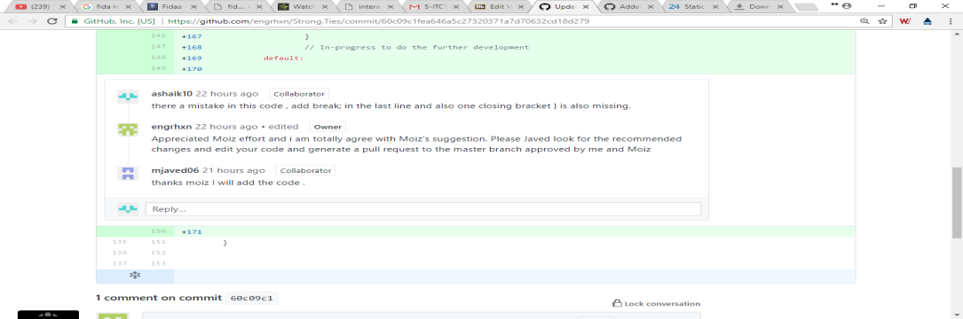

* I facilitate the code of Akshith which is in the below:

<https://github.com/engrhxn/Strong.Ties/commit/2825037740ae21f7ecbbf9114363a1bb07d52587>

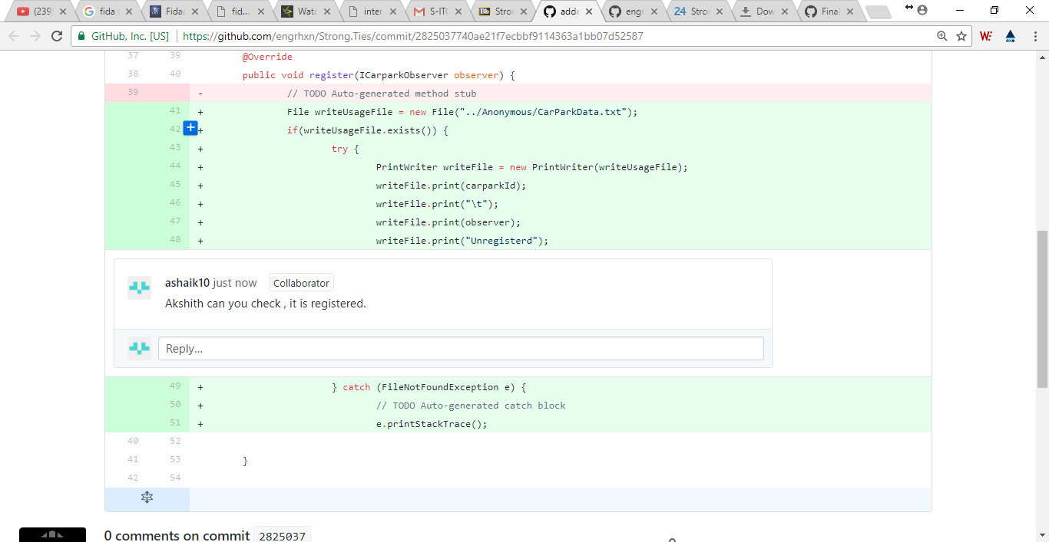

* As a mediator , I go through the Hassan code and I made a single line comment which is in the below:

<https://github.com/engrhxn/Strong.Ties/commit/7fb19742197f095858e45e2eedf72d39e9baa960>

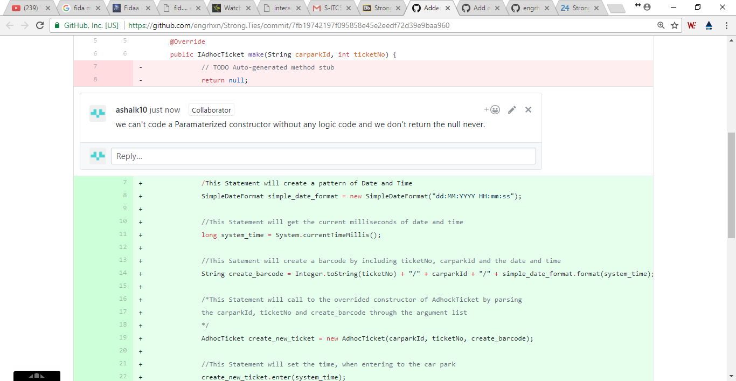

**As a Reviewer:**

I reviewed the code of Hassan which is ticket class.

Week 5_Static_Code_Review _Document_v.1.4_ Hassan in group wiki.

* <https://github.com/engrhxn/Strong.Ties/commit/23aad0a8d3f6c176bd5fda9d1184824b4008f4c4>

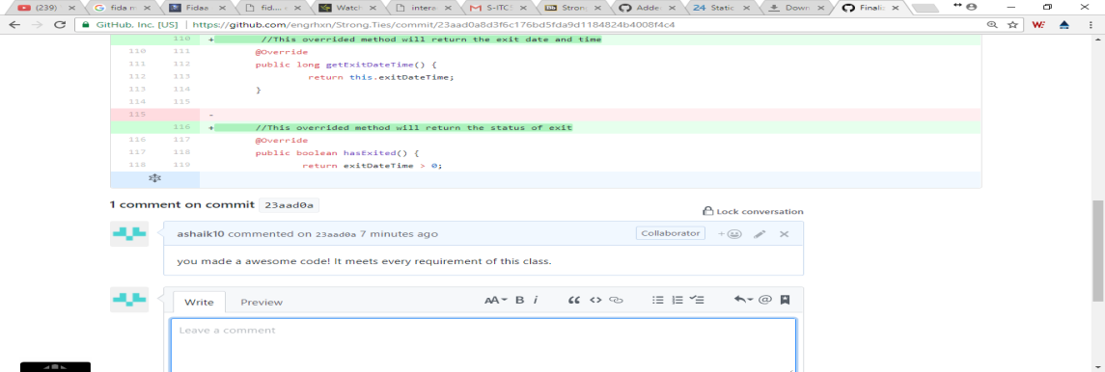

* I reviewed the Akshith code which is in the below:

<https://github.com/engrhxn/Strong.Ties/commit/91006c64cf48d247c8f6196ad2c27c8328d50407>

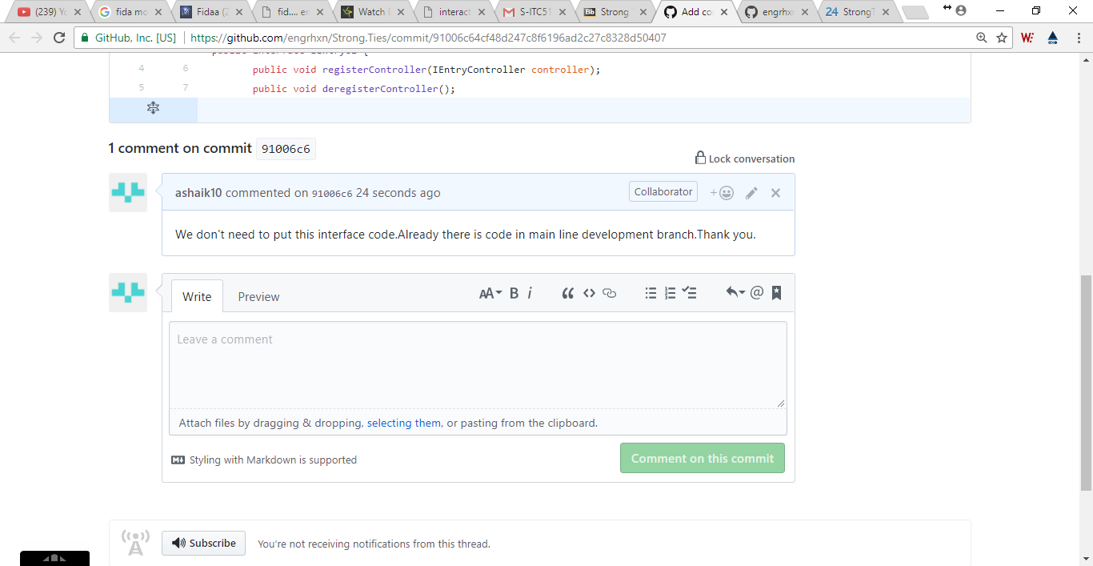

* I reviewed the code of Payment class which is in the following:

<https://github.com/engrhxn/Strong.Ties/commit/b1bd2dce058cbc2cc11b64ce2037f1f0bb8d5a67>

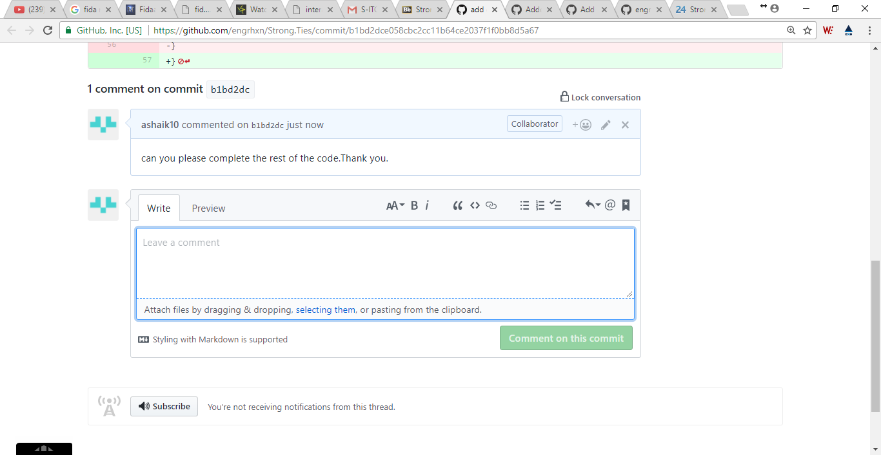

Finally, some classes merged with main line development of Master branch which is in the following:

<https://github.com/engrhxn/Strong.Ties/blob/master/src/bcccp/carpark/exit/ExitController.java>

<https://github.com/engrhxn/Strong.Ties/blob/master/src/bcccp/tickets/season/UsageRecordFactory.java>

<https://github.com/engrhxn/Strong.Ties/blob/master/src/bcccp/tickets/season/UsageRecord.java>

<https://github.com/engrhxn/Strong.Ties/blob/master/src/bcccp/tickets/season/SeasonTicket.java>